Fundamental Theorem of Arithmetic

Even though this is one of the most important results in all of Number Theory, it is rarely included in most high school syllabi (in the US) formally. Interestingly enough, almost everyone has an intuitive notion of this result and it is almost always informally covered in middle school mathematics classes in the United States.

The Fundamental Theorem of Arithmetic simply states that each positive integer has an unique prime factorization. What this means is that it is impossible to come up with two distinct multisets of prime integers that both multiply to a given positive integer.

To prove this, we must show two things:

1) Each positive integer can be prime factorized.
2) Each prime factorization is unique.

To see the first fact, let m>1 be the smallest positive integer which does NOT have a prime factorization. Since m is not a prime number, we can write m as a product of two factors, m₁ and m₂. But, since both of these are smaller than m, they DO have prime factorizations. Thus, m can be expressed as the product of these two factorizations, which creates a prime factorization contradicting the assumption that m does not have one.

Before I continue with the second part of this proof, I want to introduce pi notation, which is very similar to sigma notation:

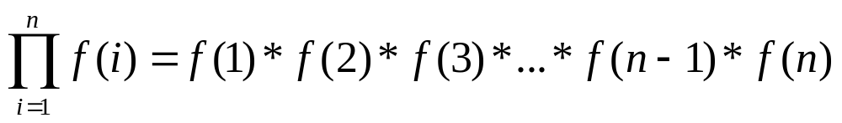

The only difference between pi notation and sigma notation is that each designated term is multiplied instead of added.

Also, I want to prove the two following lemmas:

1) If p is prime and a and b are positive integers and p | ab, then either p | a or p | b.

2) If p is prime and a_{i} for 1 ≤ i ≤ n, are positive integers, and if
p | a₁a₂... a_{n} then p | a_{i} for some 1 ≤ i ≤ n.

Proof of #1:

If p | a, we are done. Now consider the situation where p does NOT divide evenly into a. In this case, we must have that gcd(p, a) = 1. (This gcd can not be p, and p has no other possible factors, so the gcd must be 1.) Thus, there exist integers x and y such that px + ay = 1. Thus, b = b(px+ay). We can rewrite this as b = (bx)p + (ab)y. Since we know that p | p and p | ab, it follows that p | b, since b is expressed as a linear combination of p and ab.

Proof of #2

Use induction on n. We know the statement is true for n=1 and n=2. So, this takes care of the base case. Assume for n=k, we have that

If p is prime and a_{i} for 1 ≤ i ≤ k, are positive integers, and if
p | a₁a₂... a_{k} then p | a_{i} for some 1 ≤ i ≤ k.

Now, we must prove for n= k+1 that

If p is prime and a_{i} for 1 ≤ i ≤ k+1, are positive integers, and if
p | a₁a₂... a_{k+1} then p | a_{i} for some 1 ≤ i ≤ k+1.

If we have that p | a₁a₂... a_{k}, then using the inductive hypothesis, we can conclude that p | a_{i} for some 1 ≤ i ≤ k.

Otherwise, we have that p doesn't divide evenly into a₁a₂... a_{k}, so we then have that gcd(p, a₁a₂... a_{k}) = 1.

Thus, there exists integers x and y such that

px + a₁a₂... a_{k}y = 1 so,

a_{k+1}(px + a₁a₂... a_{k}y ) = a_{k+1}

(a_{k+1}x)p + (a₁a₂...a_{k+1})y = a_{k+1}

Since we have that p | p and that p | (a₁a₂...a_{k+1}), it follows that p | a_{k+1} as desired.

Now, to prove the second part of the Fundamental Theorem of arithmetic. Assume to the contrary and let n be the smallest positive integer for which there are two disctinct prime factorizations. Thus we have the following:

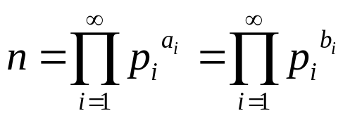

Now, let k be the smallest value for which a_{k} > 0. Then we must have that p_{k} | n. Since this is the case, and we know that p_{k} does not divide into ANY of the other primes listed thus, it follows that b_{k} > 0. But if this is the case, then we can divide both prime factorizations by p_{k} which leads to the following:

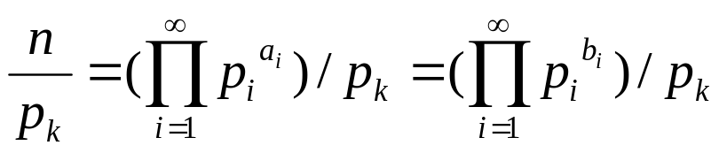

But, we know that the integer n/p_{k} has an unique prime factorization since we had assumed that n was the smallest integer without one. Thus it follows that the two prime factorizations above are identical. If that is the case, then it follows that our two distinct prime factorizations for n were not distinct at all.

Here are a couple more classic proofs from Number Theory:

The square root of 2 is irrational.

We will use proof by contradiction here.

Assume that √2 is a rational number. Then we can express √2 as a fraction of integers in lowest terms. Let √2 = a/b, where gcd(a,b) = 1. (We can do this because if we pick a and b such that their gcd is NOT 1, we can divde both integers by their gcd.)

√2 = a/b

2 = (a/b)², from squaring both sides.
2a² = b², since 2 is prime, we must have that 2 | b

Let b = 2b':

2a² = (2b')²
2a² = 4b'²
a² = 2b'², once again since 2 is prime, we must have that 2 | a.

But wait, there's a problem with that deduction. If, 2 | a and 2 | b, then the gcd(a,b) > 1. This contradicts the given information, so our initial assumption, that √2 is a rational number, is incorrect. Thus, √2 must be an irrational number.
Now we will prove that there are an infinite number of prime numbers.

Use proof by contradiction: Assume the contrary, that there are a finite number of prime numbers. In that case, they can all be listed in increasing order. Let this list be: p₁, p₂, … , p_{n}.

But, consider the number 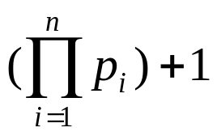 . None of the listed prime numbers divide into it. So, there are only two possible conclusions:

1) The number itself is prime.
2) The number can be written as a product of multiple numbers that are prime.

But either way, the prime numbers we obtain from this number CAN NOT be on our original list, which contradicts the fact that our original list contained ALL the prime numbers.

As an example, consider the list of prime numbers 2, 3, 5, 7. Now consider the number (2)(3)(5)(7) +1 = 211. This number turns out to be prime. Even if it didn't, it would have prime factors, but those factors could not be any of the numbers on the list.

Least Common Multiple

The least common multiple of two integers is the smallest integer that is a multiple of both integers. Consider the following examples:

lcm(12, 18) =36, since 12 | 36, 18 | 36 and 36 is the smallest integer to satisfy these constraints. (To see this, notice that the only smaller multiple of 18 is 18, which is NOT divisible by 12.)

lcm(15, 35) = 105 and
lcm(17, 19) = 323

Although there is no common algorithm typically taught similar to Euclid's algorithm to find the LCM of two integers, this can also be determined via Euclid's algorithm and one fact that we will prove about the relationship between the LCM of two integers and the GCD of two integers.

Given the prime factorization of two integers a and b, we can determine the LCM of the two integers as follows. Let

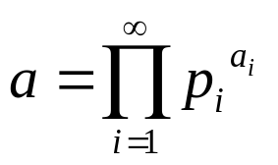 and 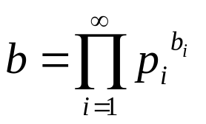

Then we have that the lcm(a,b) is

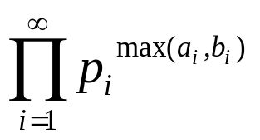

To prove this is we need to verify two things:

1) That the value above is a common multiple
2) That it is the smallest possible common multiple.'

Clearly it is a common multiple because each prime number appears in the number above at least as many times as it does in either a or b.

But, we can also show that no smaller number is possible because the minimum number of times a particular prime number must appear in the prime factorization of the lcm of a and b is precisely the maximum of the number of times it appears in either. The reasoning is as follows:

If a | b and b | c then a | c.

We know that a is divisible by p^{k}, and we are know that lcm(a,b) is divisible by a. Thus it follows that p^{k} | lcm(a,b).

This reasoning holds for each prime, this we can see that the value above is a divisor of any multiple of a and b, proving its minimality.

Using similar reasoning, we can show that the gcd(a,b) can be expressed as:

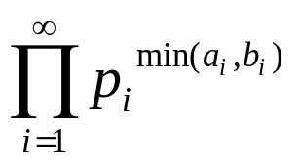

Now, with these two results, we can show the following:

ab = gcd(a,b)*lcm(a,b).
To see this, simply compute the product on the right:

gcd(a,b)*lcm(a,b) =

* =

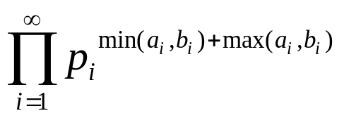=

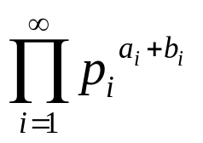=

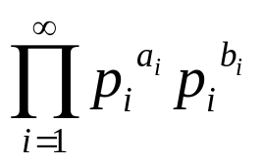=

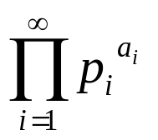*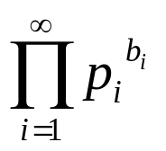=

ab

As an exercise, use this result to compute the LCM(45, 120).

